Chapter 11, Solution 73.

- 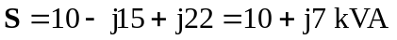
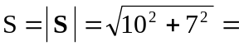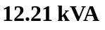

- 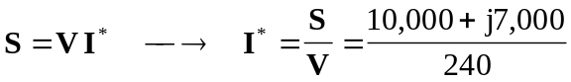

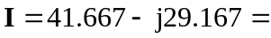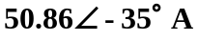

- 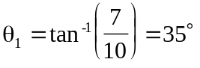, 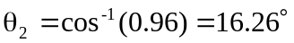

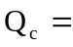

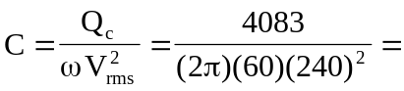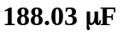

- 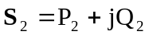, 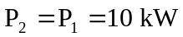

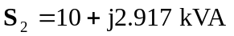
But 